# DATA

Data Style: csv file

'Player' The player

'Season' The season

'Born ' The Year the Player was born

'Age' The age of the player during the season

'Squad' The club the player was

'Nation' The Nationality of the Player

'Previous Market Value' The market value of the Player in the season before

'Market Value', The market value of the Player in the current season

'Position'

'App' Number of Appearances made in the Season

'Minutes' Number of minutes played in that season

'Goals' Number of Goals Scored

'Passes' Number of Passes made

'Assists' Number of Assists

'Yellow' Number of Yellow card received

'Red' Number of Red card received

'SubOn' Number of times subbed-on

'SubOff', Number of times subbed-off

'Shots' Number of Shots at Goal

'SOT', Number of Shots on Target

'HitPost ' Number of times the Player hit the crossbar and upright

'HeadClear' Number of Headed Clearances

'HeadGoal' Number of Goals Scored with your head

'PKScored', Number of Goals scored from the penalty spot

'FKGoal' Number of Goals scored from a direct Freekick

'Offsides' Number of Offsides

'ThrBall' Number of through passes made by the Player

'Misses' Number of shots missed/off target

'Corners' Number of corners worn

'Crosses', Number of Crosses completed

'Blocks' Number of Blocks made by the player

'Interceptions' Number of Interception made by the player

'Fouls' Number of Fouls made by the player

'Last man ' Number of Last Man tackles

'Tackles' Number of tackles made by the player

'ELG',

'OwnGoal' Number of Own goals scored

'Clears' Number of Clearances made by the player

'ABW'

'ABL'

# APPROACH

I will break-down the data into 3 different Branches each branch dedicated to a position on the field

## Forwards

Forwards are responsible for the majorly the goal scoring part of the game. Here i decided to drop all non-related goal scoring stats

Columns Kept: Goals,Assists,Market Value,Previous Market Value,SOT, Shots,Appearances, Misses,Age

I will try and find the relationship between

|  |  |
| --- | --- |
| Age | Change in Market Value |
| Goals | Change in Market Value |
| Goals per Game | Age |
| Goals per Game | Change in market Value |
| Percentage of SOT = Goals | Change in Market Value |
| Shots Accuracy | Age |

From the correlation plot below the lighter the block the more it correlates with a Change in the market value. From this we can see that Market value, Goals, Misses,SOT all have high correlation with price chan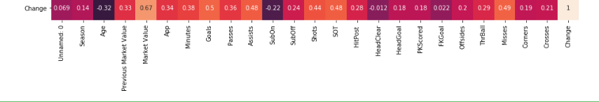ge

## Midfielders

Midfielders are responsible for the transitions from the Defense to Attack.

Columns Kept: Passes, Interception, Assists, Blocks, ThrBall, Crosses Fouls

I will try and find the relationship between

|  |  |
| --- | --- |
| Passes | Change in Market Value |
| Interception | Change in Market Value |
| Assists per Game | Age |
| Blocks per Game | Change in market Value |
| Crosses per Game | Change in Market Value |
| Assists/(ThrBall+Crosses) | Age |
| Assists/(ThrBall+Crosses) | Change in Market Value |

From the correlation plot below the lighter the block the more it correlates with a Change in the market value. From this we can see that Market value all have high correlation with price chan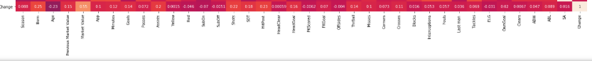ge

## Defenders

Defenders are responsible for stopping/preventing Goals

Columns Kept: Blocks, Tackles, Last Man,Headed Clear, Fouls, Passes

I will try and find the relationship between

|  |  |
| --- | --- |
| Blocks | Change in Market Value |
| Tackles | Change in Market Value |
| Last Man | Age |
| Blocks per Game | Change in market Value |
| Fouls per Game | Change in Market Value |
| Passes | Age |
| HeadClear | Change in Market Value |

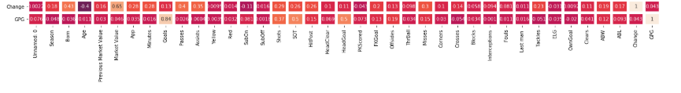From the correlation plot below the lighter the block the more it correlates with a Change in the market value. From this we can see that Market value, Passes, Assists all have high correlation with price change